Type of the Paper (Article, Review, Communication, etc.)
GEG: a serious game for teaching git and impact learning motivation, attitude, and behavior towards with Git
Firstname Lastname 1, Firstname Lastname 2 and Firstname Lastname 2,*
Affiliation 1; e-mail@e-mail.com
2 Affiliation 2; e-mail@e-mail.com
* Correspondence: e-mail@e-mail.com; Tel.: (optional; include country code; if there are multiple corresponding authors, add author initials)
Abstract: Version control system is an indispensable tool for the software industry, and engineers must have the ability to use version control tools. Most university education does not focus much on this technology, and the traditional teaching method makes students easily confused about Git and the obstacles in using it.

This study proposes a serious game called GEG to teach the concept and use of Git, with the aim of improving students' motivation and achieving deeper learning compared to traditional lectures. In this study, an experiment was designed in which two classes of the same course were divided into an experimental group and a control group. To measure the effect of the game on students, a test was designed to verify whether the game could help students achieve better learning outcomes, and a questionnaire was designed to investigate whether the game had a positive effect on students' motivation. The results showed that the game had a positive effect on students' motivation and that the experimental group had a higher pass rate than the control group for each item, although the pass rate for the most difficult items was not as high.
Citation: Lastname, F.; Lastname, F.; Lastname, F. Title. Sensors 2022, 22, x. https://doi.org/10.3390/xxxxx
Academic Editor: Firstname Lastname
Received: date
Accepted: date
Published: date
Publisher’s Note: MDPI stays neutral with regard to jurisdictional claims in published maps and institutional affiliations.

Copyright: © 2022 by the authors. Submitted for possible open access publication under the terms and conditions of the Creative Commons Attribution (CC BY) license (https://creativecommons.org/licenses/by/4.0/).
Keywords: gamification; serious games; game-based learning; motivation; educational games; version; Git; software engineering; software engineering; version control

1. Introduction
The ability to use version control tools is an essential skill for software engineers [1], but this essential skill is not always taught as part of computer science courses, and where it is taught, it is usually taught in a very short time. This has led to confusion among students regarding the concept and use of version control tools, which is further exacerbated by traditional teaching methods, making it difficult for students to be motivated to learn and to understand the content.
Among the non-traditional educational approaches, gamification is considered as a promising teaching method, and increasing user motivation is considered as a key feature of gamification [30]. Game-based learning as a teaching method can strengthen students' intrinsic motivation [2] and increase their willingness to learn actively. The virtual environment can simulate various situations that are difficult to reproduce immediately in the classroom and make teaching abstract concepts easier through interaction. Games can provide students with the opportunity to keep trying without worrying about the risk of failure, and immediate feedback increases the efficiency of learning. Therefore, gamification can effectively improve students' motivation and learning efficiency. Due to the intrinsic characteristics of games, such as competition, challenge, and interaction, they can transform the learning process into a fun experience and achieve deep learning within an acceptable teaching time and teacher burden [2].
The proposed system GEG is a web-based serious game developed by Unity combined with JSP for teaching Git concepts and commands, in order to effectively improve students' motivation and learning efficiency of Git, and to complement the insufficient parts of the school curriculum. The game divides Git concepts and commands into several levels, and introduces gamification mechanisms such as points, medals, leaderboards, etc. to motivate students to participate in learning and gain a sense of accomplishment from learning, encouraging students to keep trying in the simulated environment, while students' learning behaviors are sent to the backend database via API, so that teachers can monitor students' learning status in real time.
In addition, an educational research experiment was designed in which two classes of the same course were divided into an experimental group and a control group, and the learning effects were evaluated by using a game-based approach and a traditional approach respectively:
- Research Question 1 (RQ1): Does adding GEG as a teaching aid have higher learning outcomes than traditional teaching methods?
- Research Question 2 (RQ2): Does GEG as a teaching aid have a positive impact on students' attitude and behavior towards Git?
- Research Question 3 (RQ3): What is the percentage of students who are motivated to learn with GEG? Do students who are active learners have higher learning outcomes?
- Research Question 4 (RQ4): What do students think are the advantages and disadvantages of GEG?
To answer these research questions, this study applied and extended some of the UTAUT2 [3] and PLS-SEM [4] to examine whether the inclusion of GEG positively affected students' attitudes toward Git and to examine the effects of gamification elements on factors such as self-efficacy, performance expectancy, and hedonic motivation. This study introduced performance expectancy, effort expectancy, hedonic motivation [20], self-efficacy [21], attitudes [21], behavioral intention, use behavior, and added the effects of gamification usefulness, gamification motives to detect our design.

2. Related Works

2.1 Serious Game and Gamification
In recent decades, both "Serious Game" and "Gamification" have been used to develop for "serious" purposes. The definitions of the two are different: serious games are based on complete games, with entertainment as a secondary concern and education as the center [6][7], while gamification is the addition of game elements to non-game environments [8], but both try to use games or game elements to educate and change behavior patterns [5], and to educate, encourage, and convince users in educational, health, and other environments [9][10]. The main purpose of this study is to educate and change students' knowledge of version control software through serious games, by introducing gamification elements, establishing game mechanisms, etc. so that serious games can achieve beneficial results different from ordinary games [11].

2.2 Gamification Elements
Gamification elements as an important motivation to attract users, several gamification elements are mentioned in [12] and organized as shown in Table 1. Game elements often interrelate and can bear similar, if not the same, names. For instance, “levels” and “levelling” can refer to ranks acquired by [experience] points, as in traditional role-playing games, but can also refer to stages or areas in a game world.
Table 1. Legend of game element terminology
Term | Definition | Alternatives
Points | Numerical units indicating progress. | Experience points; score.
Badges | Visual icons signifying achievements. | Trophies.
Leaderboards | Display of ranks for comparison. | Rankings, scoreboard.
Progression | Milestones indicating progress. | Levelling, level up.
Status | Textual monikers indicating progress. | Title, ranks
Levels | Icreasingly difficult environments. | Stage, area, world.
Rewards | Tangible, desirable items. | Incentives, prizes, gifts.
Roles | Role-playing elements of character. | Class, character.
This study introduces the elements of points, badges, and leaderboards as the main game mechanics.

2.3 Educational games in Software Engineering
Traditional lectures allow only passive learning, which makes the educational software engineering process difficult to provide sufficient practical knowledge. In [31], an educational card game was developed to simulate the software engineering process, and the study describes how they designed the game mechanics to fully engage students, understand the software engineering process, and the problems they may encounter. The results showed that the game was successful in introducing students to the software engineering process, and students agreed that its inclusion in the software engineering curriculum helped them to understand software engineering concepts.
[2] described how they used the intrinsic properties of games to teach Scrum development methods to transform students' learning process into a fun experience and mentioned that games can achieve deep learning within acceptable teaching time and teacher burden. The results show that the competitive nature of the game stimulates students' engagement in learning and positively affects their learning experience and motivation. Therefore, this study also chose to include competitive elements such as leaderboard mechanism to stimulate students' learning motivation.

2.4 Industry Expectations and Computing Education
In the study of graduates' ability to enter the labor market, team skills, collaboration and tools for these skills were mentioned as needing improvement. The difference between industry expectations and graduate competencies is mentioned in [13], and the competencies mentioned in the literature are related to how the team manages the software. [14] mentions Git as a well-established and well-regarded version control system for code. He also mentions that students with little experience in industry standard tools are sufficiently limited in their ability to participate in internships and describes how he introduced Git as a mechanism for publishing course exercises. [15] presented their experience of using Git as a platform for their courses in computer science and argued that from a curriculum perspective Git should be used as a foundation for programming rather than software engineering. To summarize the above, this study therefore proposes a Git-themed gamification education experiment to enhance students' mastery of Git and their motivation and attitude towards learning.

2.5 UTAUT
The UTAUT model consists of six main structures, the UTAUT model integrates eight major theories of technology acceptance [25], [26] studied students' acceptance of digital learning at five universities, and the UTAUT2 model integrates the Technology Acceptance Model (TAM) [27], which found that computer self-efficacy and computer gameplay had significant effects on the perceived ease of use of e-learning systems. [28] studied the effect of gamification on the use of mobile banking services and the results of the study showed a direct and strong relationship between gamification and intention to use mobile banking services. Therefore, it is the most suitable model for our study to develop and validate the theory.

3. GEG
GEG simulates development situations and a Git Command Line (Git CLI), in which the player must operate a Git CLI simulated by the game. The game is divided into ten levels, with each level representing one or more Git commands or concepts, except for the first and second levels, which are the introductory chapters of the game. Students must use in-game prompts to learn and try out the operations in each level, and eventually achieve the task goals and pass the level.
The levels in the game are progressively more difficult, with the initial levels being completed by simply following the prompts and entering instructions, and the subsequent levels requiring the player to learn to apply the concepts of the previous levels to get the correct answers. Players will earn points when they pass the levels, as well as badges and points for achieving certain special conditions, and these results will be presented on the leaderboard to motivate students.

3.1. Game Design Principle
This study adopts the design principles proposed by [32] to combine flow experience with instructional design to create a highly immersive gaming experience, which in turn makes the learning process more effective, so the system proposed in this study is designed in the following steps:
- Analyze learners:
Our learners are mainly second-year college students in computer science with basic programming skills, but most of them do not have the ability to use version control tools, and most of them do not have long-term experience in maintaining projects or developing large projects. Therefore, they need to be equipped with basic knowledge of version control and the ability to use version control tools.
- Set clear teaching objectives and select appropriate gaming material:
The educational goal of this study was to equip students with the ability to use Git commands such as creating a git repository, commit, push, etc., and to understand the reasons for using version control tools and the workflow of Git. Therefore, this study chose to use a simulated development scenario in which students operate a simulated Git tool in a game to accomplish the task goals we set.
- Design teaching instructions according to teaching objectives and game content:
In this study, Git instructions were designed as several levels, and students were asked to complete the tasks we set in a simulated situation. Students are provided with in-game mechanisms as learning aids, and the competitive game mechanics and rewards we designed can motivate students to participate in the learning process and increase their motivation to learn.
- Consider teaching as the primary goal and use games as supplementary tools:
In this study, GEG is taught as part of the curriculum, and Git is taught in a traditional lecture format in subsequent classes, so that students who have difficulty learning can play games for self-directed learning and choose a learning style that suits them.
- Make good use of the characteristics of computer games:
Our game is a simulation game with some features of a competitive game, which brings the opportunity and motivation to try again and again by the characteristics of a computer game, and the hints and instruction cards are used as tools to assist students' understanding.
- Place students at the center of the process and help them enjoy studying:
In the learning process, based on the game's points mechanism, achievement mechanism, etc., students take the initiative to try various possibilities and increase the motivation to actively participate in learning, so that students can learn more about Git and how to use it.
- Periodically assess students’ learning and constantly improve teaching:
Students' activities are recorded and sent to the backend of the server. From the number of levels passed, the number of instructions spent by students, the time spent by students, etc., we can determine the learning status of students and immediately adjust levels that may be too difficult or add more levels to help students clarify confusing concepts. In addition, tests and surveys are also conducted to understand students' learning status.
According to Bloom's taxonomy [33], this study classifies the Git competencies acquired by students in terms of knowledge, understanding, application, etc. as follows:
- Remember:
Students can remember the conceptual terms and some of the commands associated with Git, such as: repository, commit, branch, merge, etc.
- Understand
Students can understand the difference between local and remote repository, the difference between Git and Git server, the role of distributed version control system, the role and function of branch, the role of merge, and how to resolve conflicts in the context of a hands-on, prompted, and visualized Git workflow concept.
- Apply:
Students will gain the ability to use various commands or solve Git-related problems, such as clone, commit, push, pull, create branch, merge, and conflict solve, through repeated practice.
- Analyze:
Through progressive levels, students must understand the previous levels before they can pass the subsequent levels. This enables students to understand the function and difference of each command or Git concept, and eventually learn the overall workflow and concepts of version control tools and Git.

3.2. Overall Design
The game in this study is web-based, students must enter the game URL before they can start playing the game. Figure 1 shows the start menu, where students are required to register with a student number to start the game, and Figure 2 shows the chapter menu, where the Git concepts and commands we teach are included in the levels, and students must pass the corresponding levels to unlock the subsequent levels.
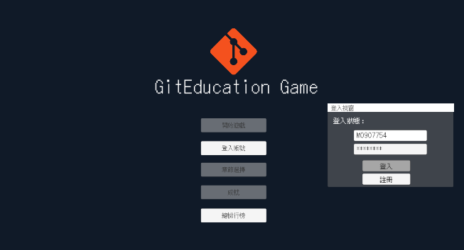
Figure 1. Start menu: Students must register and log in to their account before they can start playing the game.
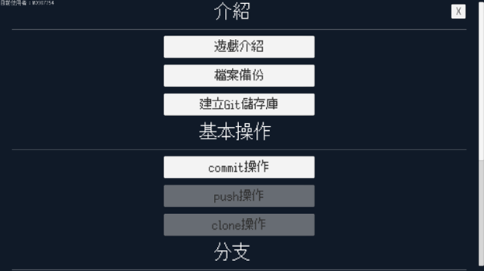
Figure 2. Chapter menu: List of levels in the game, a level or chapter represents a Git concept and instruction.
In addition, the reasons for adopting the teaching CLI in this study are as follows:
- It is easy for beginners to use the GUI directly to confuse their understanding of how Git works, and they may mistake the functions designed by the GUI as direct functions of Git.
- The Git CLI is the same on all environments and machines, while the GUI may not work due to different operating systems.
- The CLI is more complete than the GUI, in that all of Git's features are included, while the GUI is not.
- It's easier to get help when you're having trouble using it, as the GUI doesn't always have complete and good documentation, while the CLI makes it easier to get help online.
Also learning Git in a graphical interface was observed to be confusing for students although it could prevent them from not adapting to the command line interface, so using the CLI may be the first choice for students [15] .

Before students officially start the first level, students will first enter level 0, as shown in Figure 3, which will explain to students how the game works.
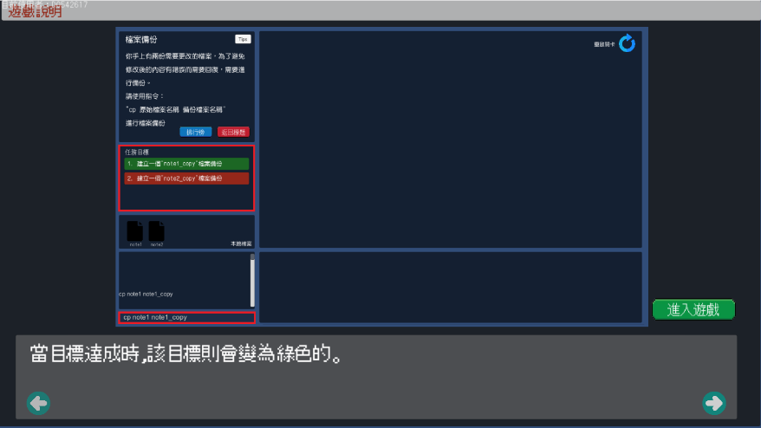
Figure 3. Level 0 introduce players to how the game is played.
Figure 4 shows the game interface, which is divided into six blocks, with the following numbers corresponding to the identification numbers in the picture.
- The brief description of the level and the instructions of the level open button.
- The task objective of the level, the completed objective will be shown in green, otherwise it will be shown in red.
- The file section, where students must sometimes manipulate files to modify and save them.
- The Git console interface, where students must enter the appropriate Git commands.
- The Git visualization block, which contains the remote (top half) and local (bottom half) sections of Git, with a level restart button in the upper right corner for when students are using irreversible operations.
- The Git command prompt card associated with the level, which will be enlarged when you move your mouse over it.
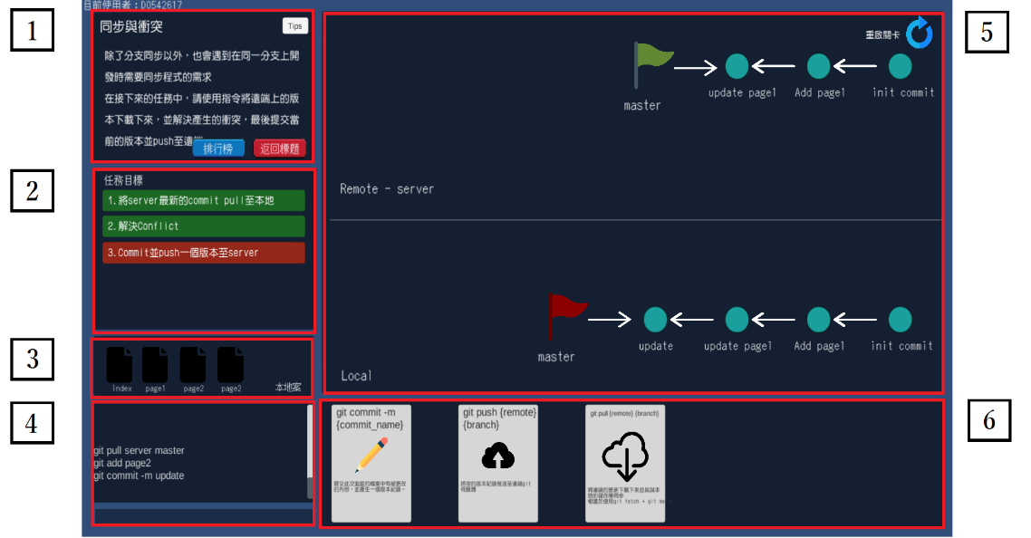
Figure 4. The six blocks of the game.

Once the student enters the level, the instructions are automatically turned on, as shown in Figure 5, and closed when they reach the last page, or can be closed immediately by hand, and the student must follow the instructions to complete the target.
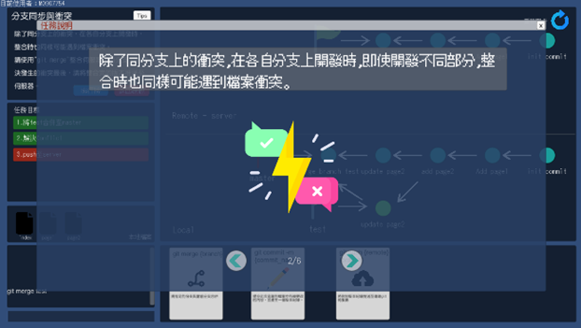
Figure 5. Game main menu.
Figure 6 shows that when a level is completed, in addition to the basic congratulatory message, the time spent and the number of commands entered in the level are also displayed to the students. These records are sent to the server database, which can be used for subsequent analysis and also as part of the in-game leaderboard.
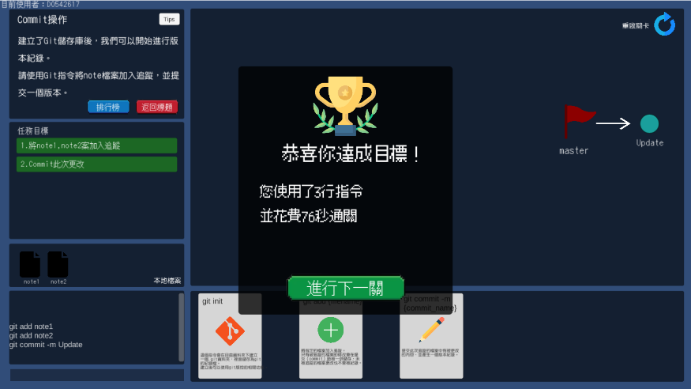
Figure 6. Level Passed.

3.3. Gamification Elements

To attract students to actively learn Git in this study, the following gamification elements were introduced in GEG: points, leaderboards, and badges.

3.3.1. Points

As one of the most common game elements [12], Star [29] found that the mere use of points adds a quantitative indicator of task performance. As students pass each level, they are awarded points. To match the progressive difficulty of the levels, the later the level is passed, the more points the student earns, which allows the student to view his or her progress, and the points are used as a basis for ranking the leaderboard, which the player can open from the start menu to see his or her total score.

3.3.2. Leaderboards

The leaderboard is also one of the most common game elements and the main gameplay of GEG, and there are two types of leaderboards in GEG: the first is the level leaderboard, which ranks students according to their time spent on the level. The ranking record of level 4 is shown in Figure 7.
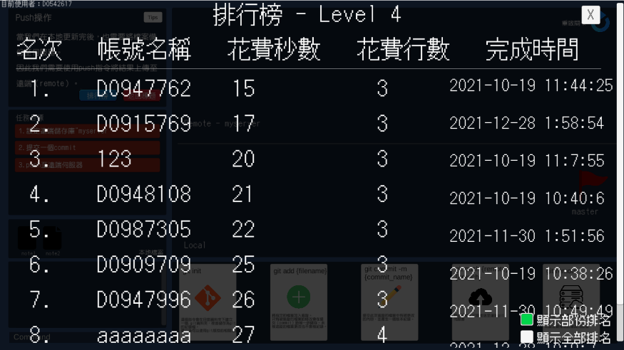
Figure 7. Level4 leader board.

The second one is the overall ranking, as shown in Figure 8, where students are ranked according to the number of points they have earned throughout the game levels, and the number of achievements they have earned is also listed.
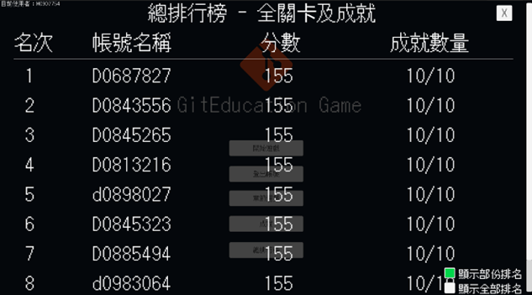
Figure 8 Global leader board.

Considering that the ranking may be counterproductive for students with lower rankings [16], GEG set a switch to control whether or not to display all rankings, which is placed at the bottom right corner of the ranking interface, and by default only some of the rankings (top 10) are displayed.

3.3.3. Achievement and badges

Badges are usually used to symbolize the player's achievements and provide a unique marker for achievements [17], and visual achievements represent a reward in themselves. There are ten achievements in GEG, which can be earned when students complete specific tasks. Students who earn achievements not only collect badges but also earn a certain amount of points, this encouraging students to complete specific actions to rank higher in the leaderboard. For example, when students pass the first level of the game, they can get an achievement called "Getting Started", Figure 9 shows the screen that pops up when students get the achievement.
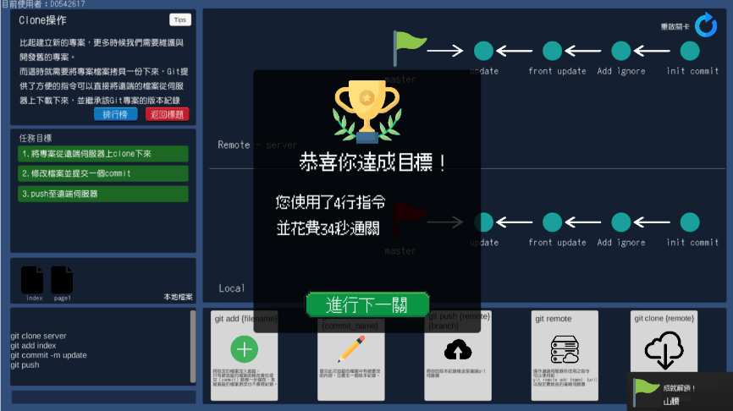
Figure 9. Getting achievement.

In addition, students can also get an achievement when they are the first in a level ranking, or when they pass a level in 30 seconds, and GEG has also set up some interesting achievements, such as the achievement called "I don't need hints" when students close the game without reading a page of instructions, or the achievement called "King of card" when students read a card more than 25 times. These achievements increase student engagement, encourage students to try as much as possible during the game, and increase replayability.

Figure 10 shows the achievement viewer, where students can view their currently unlocked achievements and also view those that have not been unlocked. The unlocked achievements are hidden from view on the Achievements viewer, but the descriptions of the achievements provide an idea of what needs to be achieved in order to encourage students to try to accomplish these goals.
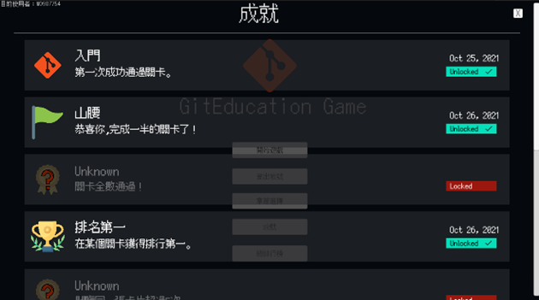
Figure 10. Achievement viewer.

3.4. Level topics And Student’s Activities Monitoring

In GEG, the first level of the game (the game introduction is in level zero) introduces why you need to use version control software, and the remaining eight levels in total teach Git commands and concepts directly, on the following topics:
- Create a Git repository (git init).
- Commit operations (git commit).
- Push operations (git push).
- Create a branch (git branch).
- Merge and delete branches (git merge and git branch -D).
- Synchronize and conflict (git pull and conflict solve).
- Git merge and conflict solve.

Students' activities in GEG will be recorded and sent to the database, so that teachers can know the status of students' learning in real time. These activities include:
- Student starts the level.
- Student complete an objective in the level.
- Student completes the level (including time spent and number of lines).
- Student turns on the in-game hint
- Student closes the in-game hint.
- The commands entered by the student in the CLI.
- The student's current number of badges.
- The number of students who have passed each level.
Teachers can check the number of students who passed each barrier to determine whether students encountered difficulties in certain areas. For example, in Figure 11, we checked the pass record of level 8 and level 9 during the experiment day and observed that only about 50% of the students passed the levels, so the teacher can know that the students did not fully understand and master branch merging, conflict resolution, etc. immediately.
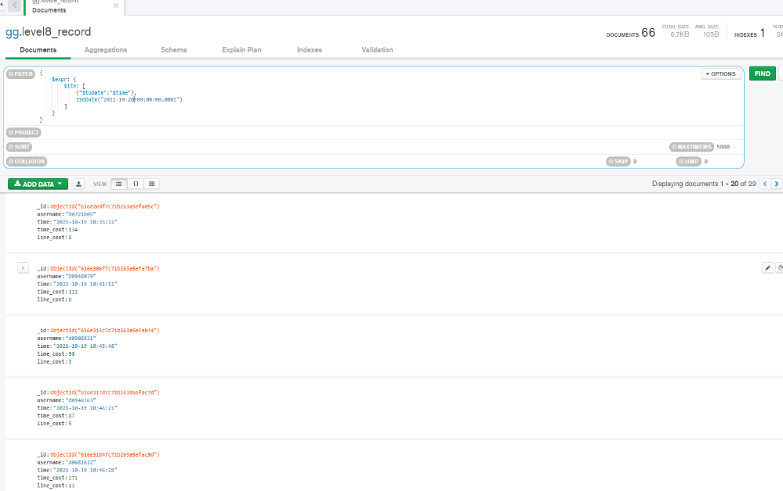
Figure 11. Level 8 Record.

4. Experiment
To validate our system, this study was conducted in an object-oriented programming course in the first semester of the 110th academic year at Feng Chia University, Taiwan. The course was divided into two classes, with one group randomly selected as the experimental group and the other group as the control group, with 54 and 59 students respectively. Most of the students in this course were sophomore computer science students. In addition, the learning platform used in this OOP course required the use of Git to upload their homework (including but not limited to CLI).

4.1. Procedure
The flow of the experiment is shown in Figure 12. Before the start of the experiment, the experimental and control groups were given a non-practical Git tutorial and a multiple-choice pre-test to determine whether the students had the same benchmarks. In the following week of the pre-test, the experimental and control groups were given a Git course, ranging from setting up the git repository to resolving conflicts, for two hours, while the experimental group was given one hour of game time and one hour of course instruction (the same scope as the control group). To allow time for students to absorb the knowledge, post-tests are scheduled a few weeks later.
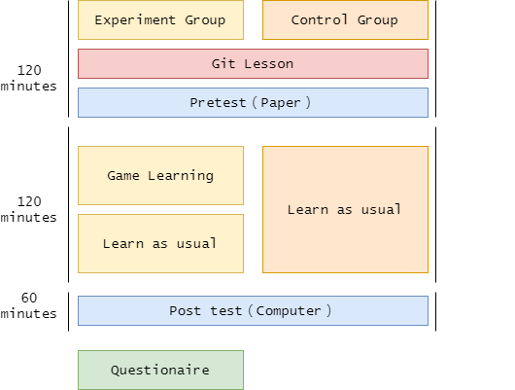
Figure 12. Experiment procedure
In the experimental group, students were first taught how to operate the GEG game and were shown how to pass the first level, and then allowed to learn on their own. In the second hour, the same content was taught as in the control group, and the scope of instruction was the same as that taught in the game levels, as shown in Figure 13, where students played the game and learned the concept and use of Git.
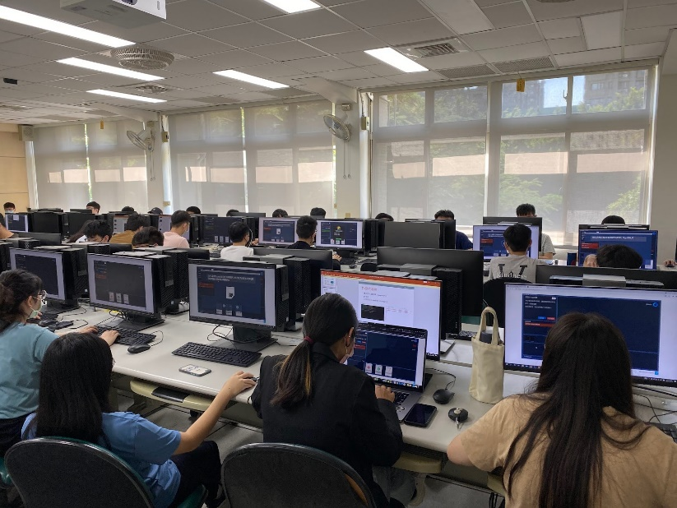
Figure 13 Students learn through games in the classroom
The post-test was an online examination on computer operation where students used a pre-created private Gitlab to take the exam. The exam was given in one hour, and the scope of the questions included content taught previously such as clone, commit, push, branch, resolving conflicts, and so on, for a total of three questions.
After the test was completed, students were asked to fill out a questionnaire about their gaming experience and attitude towards Git. There were 25 items divided into ten categories (Performance Expectancy, Effort Expectancy, Self-Efficacy, Hedonic Motivation, Gamification Motivation, Gamification Usefulness, Behavioral Intention, Use Behavior) and two open-ended questionnaires. This questionnaire investigated students' experience with the system, including the usefulness of the game for learning Git and whether it brought motivation to learn. This study used a five-point Likert scale to measure the items we designed, ranging from 1 (strongly disagree) to 5 (strongly agree) The model structure is shown in Figure 14.
PLS-SEM path modeling is used appropriately and is considered to estimate causal models in a context characterized by many empirical data [18], and it requires a low sample size [19]. The tolerance of small sample size is the main reason for its adoption in this study, and PLS-SEM detects causal and independent variables with measurement and structural models [18].
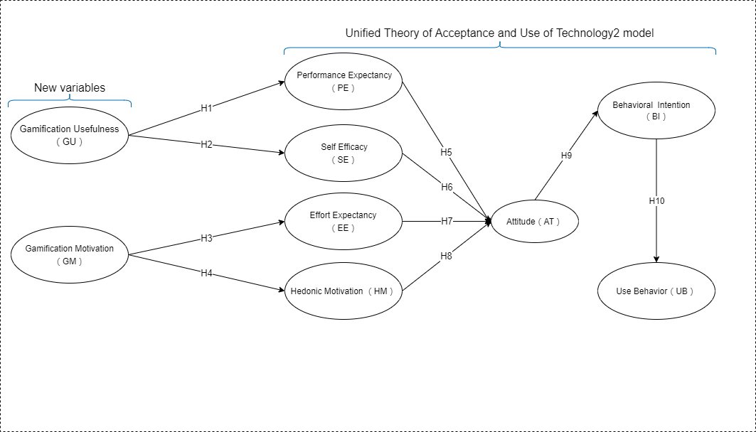
Figure 14. Research model.
The following assumptions are made based on the relationship between the various components of the study model:
- Hypothesis 1 (H1): The mechanism of gamification affects students' performance expectancy using games to learn Git.
- Hypothesis 2 (H2): The mechanism of gamification affects students' self-efficacy in using the game to learn Git.
- Hypothesis 3 (H3): The gamification mechanism affects students' effort expectancy using the game to learn Git.
- Hypothesis 4 (H4): The mechanism of game-playing affects students' hedonic motivation to use the game to learn Git.
- Hypothesis 5 (H5): Performance expectancy of learning Git using games affects students' attitudes towards Git.
- Hypothesis 6 (H6): Self-efficacy in learning Git using games affects students' attitudes towards Git.
- Hypothesis 7 (H7): Effort expectancy of using the game to learn Git affects students' attitudes towards Git.
- Hypothesis 8 (H8): Hedonic motivation to use games to learn Git affects students' attitudes towards Git.
- Hypothesis 9 (H9): Students' attitudes towards Git will influence their behavioral intentions towards Git.
- Hypothesis 10 (H10): Students' behavioral intentions towards Git will affect their use behavior use of Git.

4.2. Result

4.2.1. Pre-test Result
Regarding the results of the pre-test as shown in Table 1, this study used independent sample t-assay to compare whether there was a difference between the mean of the control group and the experimental group. 54 samples were sampled from the control group and the mean was 72.593; 59 samples were sampled from the experimental group and the mean was 76.271.
In the homogeneity of variance test, the value of the test statistic f was 1.1761 and the value of the probability p was 1.4487, which did not reach the significant level of α=0.05, indicating that there was no significant difference in the variance between the two groups.
In the independent sample t-assay, the t-value of the validation statistic was -1.1918 and the p-value of the odds ratio was 0.2359, which did not reach the significant level of α=0.05. Therefore, the null hypothesis could not be rejected, indicating that there was no significant difference between the means of the control and experimental groups.
Table 1. Pre-test results for experiment and control groups
Group | Count | Mean | Median | Minimum | Maximum | Std. dev.
Control group | 54 | 72.5926 | 70 | 40 | 100 | 15.6838
Experiment group | 59 | 76.2712 | 80 | 30 | 100 | 17.0090

4.2.2. Post-test Result
In the post-test section, echoing the hypothetical questions of the study, the requirements of the test questions are divided into three parts:
- Be able to fork projects and perform clone, commit and push.
- Be able to add a new branch and switch branches for commits.
- Be able to merge and resolve conflicts.
In the post-test results, 73% of the students in the experimental group were able to pass Question 1, while 64% of the students in the control group were able to pass Question 1; 64% of the students in the experimental group were able to pass Question 2, while 50% of the students in the control group were able to pass Question 2; 43% of the students in the experimental group were able to pass Question 3, while 33% of the students in the control group were able to pass Requirement 3. Figure 15 shows the pass rates of the two groups for the three questions.
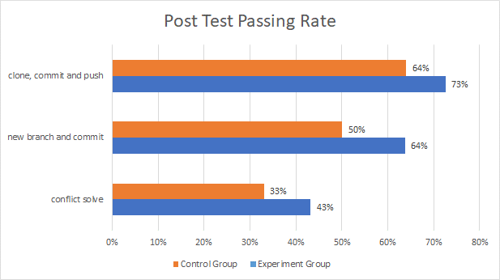
Figure 15. Post-test passing rate

4.2.3. Questionnaire Result
Regarding the results of the questionnaire survey as shown in Table 2, we collected 39 valid questionnaires, of which about 22 students filled in the open-ended questions about their opinions on GEG. The students' agreement level was high for most of the questions, however, we did observe a significantly lower value in UB1
Table 2. Questionnaire’s results
# | Questions | Mean | Std
PE1 | I learned faster with GitEducation Game | 4.1026 | 0.8824
PE2 | Using GitEducation Game has improved my learning | 4.0769 | 0.8701
EE1 | GitEducation Game is not too taxing to use | 3.8974 | 1.0462
EE2 | The features and interface of GitEducation Game are very clear and easy to understand | 3.8974 | 0.9678
SE1 | When there is an error with Git, if there is no one around to teach me, I can play the GitEducation Game to understand and solve the problem | 3.8205 | 0.9966
SE2 | When I have trouble learning Git, I can use the GitEducation Game to clarify the concepts or operations of Git if there is no one around to teach me how to do it. | 3.7949 | 1.0047
HM1 | I think learning Git through the GitEducation Game is fun | 4.1282 | 0.7320
HM2 | I think learning Git through the GitEducation Game gives me more motivation | 4.0513 | 0.7930
GM1 | When I learn with GitEducation Game, the in-game score and leaderboard system makes me more motivated to participate in learning | 3.8974 | 0.9946
GM2 | The achievement system in the game gives me more motivation to learn with GitEducation Game | 3.9487 | 0.9986
GM3 | The in-game hints and tutorials give me more motivation to understand Git concepts than a pure lecture. | 4.1538 | 0.8441
GU1 | When learning Git with the GitEducation Game, the in-game hints or tutorials help me understand the Git concepts being taught in the levels. | 4.1795 | 0.7564
GU2 | When learning Git with the GitEducation Game, I can understand how to use the Git commands by completing the levels | 4.1538 | 0.7793
GU3 | When learning Git with the GitEducation Game, the visualization, and mechanics of the game help me understand the concept or process of working with Git. | 4.0256 | 0.9315
AT1 | I think that using version control tool to control source code is a good idea | 4.3077 | 0.7662
AT2 | Studying to use version control tool is a good idea | 4.4103 | 0.7511
AT3 | I generally favour the use of verson control tool | 4.3590 | 0.7776
AT4 | I am positive towards the use of version control tool | 4.2051 | 0.8639
BI1 | I intent to use version control tools in the future | 4.1538 | 0.9330
BI2 | I intend to use version control tools frequently | 4.0513 | 0.9445
BI3 | I intend to be a heavy user of version control tools | 4.1282 | 0.9509
UB1 | I use version control tool in frequenly in all my software projects | 3.4359 | 1.3533
UB2 | I recommend my classmate to use version control tool like me | 4.0000 | 1.0260
OEQ1 | What do you think makes GitEducation Game appealing to you in terms of teaching or gaming? Or what are the learning benefits for you? | X | X
OEQ2 | What do you think are the shortcomings of the GitEducation Game in terms of teaching or gaming? Or what is missing in teaching? | X | X

4.3. Reliability and Validity Test
Regarding the results of the model, in order to calculate the reliability, internal consistency and convergent validity of the items, the measurement model was evaluated using the PLS algorithm and the results are shown in Table 2 and Figure 16.
If the indicators are highly correlated and interchangeable, they are considered reflective and should be checked for reliability and validity [22].' CL', 'α', and 'CR' should be greater than or equal to 0.7, and 'AVE' values should be greater than 0.5 [23].
As shown in Table 3, all cross-loading values are above 0.764 and Cronbach's alpha values are above 0.801, which indicates that the reliability of the measured model is good and all composite reliability values are above The average variance extracted was above 0.708, indicating a high degree of convergence calibration.
Table 3. Internal consistency, item reliability, and convergent validity.
Constructs | Items | CL(>0.7) | α(>0.7) | CR(>0.7) | AVE(>0.5)
Gamification  Usefulness | GU1  GU2  GU3 | 0.894  0.988  0.904 | 0.920 | 0.950 | 0.864
Gamification  Motivation | GM1  GM2  GM3 | 0.875  0.898  0.764 | 0.801 | 0.879 | 0.708
Performance  Expectancy | PE1  PE2 | 0.996  0.996 | 0.992 | 0.996 | 0.992
Effort  Expectancy | EE1  EE2 | 0.927  0.964 | 0.886 | 0.944 | 0.895
Self-Efficacy | SE1  SE2 | 0.983  0.984 | 0.966 | 0.983 | 0.967
Hedonic  Motivation | HM1  HM2 | 0.954  0.954 | 0.901 | 0.953 | 0.910
Attitude | AT1  AT2  AT3  AT4 | 0.893  0.920  0.943  0.929 | 0.941 | 0.957 | 0.849
Behavioral  Intention | BI1  BI2  BI3 | 0.973  0.973  0.977 | 0.973 | 0.983 | 0.950
Use Behavior | UB1  UB2 | 0.938  0.937 | 0.862 | 0.936 | 0.879
* Notes: CL - cross loadings; α - Cronbach’s alpha; CR - composite reliability; AVE - average variance extracted.
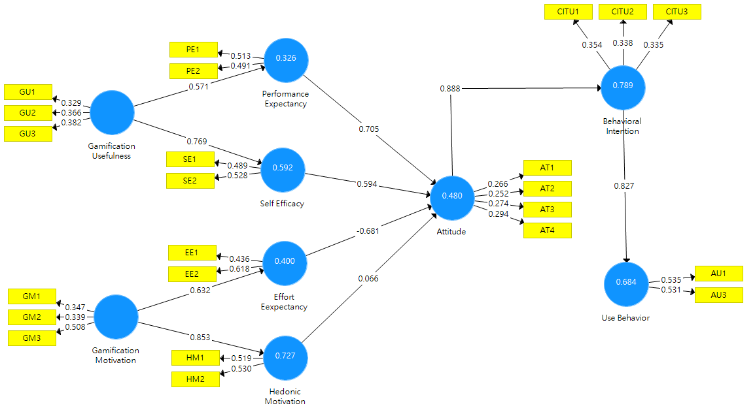
Figure 16. Measurement results of PLS-Algorithm
An important step in model validation is also the discriminant validity of the Fornell-Larcker criterion analysis, where the results are considered acceptable when the diagonal values are higher than the cross-loading values of the other constructs [23]. A good discriminant validity indicates that the structure has sufficient convergence calibration, and the results of the analysis are shown in Table 4.
Table 4. Results of the Fornell-Larcker criterion analysis (discriminant validity test).
 | UB | AT | BI | EE | GM | GU | HM | PE | SE
UB | 0.938
AT | 0.793 | 0.921
BI | 0.827 | 0.888 | 0.974
EE | 0.371 | 0.345 | 0.411 | 0.946
GM | 0.525 | 0.483 | 0.500 | 0.632 | 0.841
GU | 0.442 | 0.393 | 0.413 | 0.605 | 0.765 | 0.930
HM | 0.421 | 0.461 | 0.334 | 0.584 | 0.853 | 0.767 | 0.954
PE | 0.425 | 0.492 | 0.447 | 0.848 | 0.617 | 0.571 | 0.640 | 0.996
SE | 0.677 | 0.568 | 0.667 | 0.656 | 0.797 | 0.769 | 0.574 | 0.541 | 0.984
* Notes: UB - use behavior; AT - attitude; BI - behavior intention ; EE - effort expectancy; GM - gamification motivation ; GU - gamification usefulness; HM - hedonic motivation; PE - performance expectancy; SE - self-efficacy.

4.4. Assessment of structural model
We evaluated the relationship between potential variables in the structural model. We used the blindfolding technique to evaluate the predictive relevance of the study model, under which a model is considered to have predictive relevance if the cross-validated redundancy measure "Q²" is greater than zero. The model is considered to have predictive correlation when the cross-validated redundancy measure "Q²" is greater than zero, and is considered to have small predictive correlation when it is greater than 0.02, medium predictive correlation when it is greater than 0.15, and large predictive correlation when it is greater than 0.35. The explained variance "R²" is considered "substantial" when it is greater than 0.67 [18][23], and the results are shown in Table 5.
Table 5. Explained variance (R2) and predictive relevance (Q2).
Dependent variables | R² (>0.5) | Q² (>0) | Result
Performance Expectancy | 0.327 | 0.306 | weak
Self Efficacy | 0.592 | 0.670 | moderate
Effort Expectancy | 0.400 | 0.314 | weak
Hedonic Motivation | 0.727 | 0.583 | moderate
Attitude | 0.480 | 0.378 | weak
Behavioral Intention | 0.789 | 0.741 | substantial
Use Behavior | 0.684 | 0.593 | moderate
P-values were obtained by Bootstrapping with two-tailed checks, Bootstrapping was randomized on the original dataset to estimate the statistical significance of the PLS path model [22][24], the results are shown in Table 6, some of the internal path coefficients are statistically significant. It was found that " Gamification Usefulness" had effect on "Performance Expectancy" ( p = 0.000, t = 3.946 ) and "Self-Efficacy" ( p = 0.000, t = 13.693 ); thus H1, H2 are supported." Gamification Motivation" had effect on "Effort Expectancy" ( p = 0.000, t = 6.648 ) and "Hedonic Motivation " ( p = 0.000, t = 28.222 ); therefore, H3, H4 are supported. Performance Expectancy" ( p = 0.012, t = 2.516 ), " Self-Efficacy" ( p = 0.008, t = 2.663 ), " Effort Expectancy" ( p = 0.007, t = 2.701 ) had a significant effect on "Attitude" and therefore H5, H6, H7 were supported." Attitude" had effect on "Behavior Intention" ( p = 0.000, t = 20.191 ) and "Behavior Intention" had effect on “Use Behavior” ( p = 0.000, t = 16.097 ).; thus H9, H10 are supported.
Unexpectedly, H8 was not supported and "Hedonic Motivation" ( p = 0.740, t = 0.332) could not be predicted for "Attitude".
Table 6. Results of testing study hypotheses related to direct effects (p∗∗ <= 0.01, p∗ <= 0.05).
H | Relation | Original  Sample(O) | Sample  Mean  (M) | Standard  Deviation  (SD) | T  Statistics  (>1.96) | P  Values  (<0.05)
H1 | GU->PE | 0.571 | 0.567 | 0.145 | 3.946 | 0.000
H2 | GU->SE | 0.769 | 0.776 | 0.056 | 13.693 | 0.000
H3 | GM->EE | 0.632 | 0.638 | 0.095 | 6.648 | 0.000
H4 | GM->HM | 0.853 | 0.869 | 0.030 | 28.222 | 0.000
H5 | PE->AT | 0.705 | 0.676 | 0.280 | 2.516 | 0.012
H6 | SE->AT | 0.594 | 0.617 | 0.223 | 2.663 | 0.008
H7 | EE->AT | -0.681 | -0.670 | 0.252 | 2.701 | 0.007
H8 | HM->AT | 0.066 | 0.070 | 0.200 | 0.332 | 0.740(NS)
H9 | AT->BI | 0.888 | 0.890 | 0.044 | 20.191 | 0.000
H10 | BI->UB | 0.827 | 0.890 | 0.044 | 16.097 | 0.000
* Notes: UB - use behavior; AT - attitude ; BI - behavior intention ; EE - effort expectancy; GM - gamification motivation ; GU - gamification usefulness; HM - hedonic motivation; PE - performance expectancy; SE - self-efficacy; H - hypothesis; NS - non-supported.

5. Discussion

In the previous section, the experimental results were presented and the structural model was analyzed and validated. In this section, the experimental and structural model results are used to respond to the stated research questions.

5.1. Research Question 1 (RQ1): Does adding GEG as a teaching aid have higher learning outcomes than traditional teaching methods?
Regarding research question 1, the post-test results showed that the experimental group passed all three requirements better than the control group, so adding GEG as a teaching aid has higher learning outcomes than the traditional teaching method.
However, the pass rate of the conflict resolution questions was not high. We believe that this is because there are no collaborative assignments or projects in the course, so the branching and merging function is not needed by most students, and the relatively low pass rate for this requirement is due to the higher learning difficulty.

5.2. Research Question 2 (RQ2): Does GEG as a teaching aid have a positive impact on students' attitude and behavior towards Git?
Regarding research question 2, it is important to look at the results of the measurement model. First, according to the supported hypotheses of H1, H2, H3, and H4, the gamification element of the GEG design positively influenced students' perceptions of learning Git; according to the supported hypotheses of H5, H6, and H7, performance expectations, effort expectations, and self-efficacy assessments positively influenced their attitudes toward learning and using Git; and according to the supported hypotheses of H9 and H10, attitudes toward Git influenced students' subsequent use of Git. The hypotheses of H9 and H10 were supported by the hypotheses of H5, H6, and H7, which showed that the students' attitudes toward learning and using Git had a positive impact on the students' willingness to use Git and further influenced their subsequent use behavior.
Therefore, it can be concluded that GEG as a teaching aid can positively influence students' attitudes towards learning and using Git, as well as their subsequent behaviors. In addition, it is surprising that H8 did not hold true, as this study suggests that it is because hedonistic motivation cannot directly affect the attitude towards Git, but only enhances students' motivation when engaging in learning.

5.3. Research Question 3 (RQ3): What is the percentage of students who are motivated to learn with GEG? Do students who are active learners have higher learning outcomes?
Regarding research question 3, first of all, our records show that about 55 students participated in Git's teaching activities, but there were 98 accounts, most of which were registered after the experiment ended and came from the school's IP, presumably by students who forgot their passwords and repeatedly registered, while a small number (about 14) were accounts with no activity at all, mostly registered as Most of them were accounts registered as non-school numbers, which were abandoned by students. Among the 55 students, about 34 of them still had activity records after the experiment, which means that at least 60% of the students had active learning with GEG.
Since many of the post-experimental activity accounts were not named by student number, only about 27 students named by student number with active learning were selected for comparison with the entire experimental group. We found that students with active learning had better results in all areas, as shown in Figure 17.
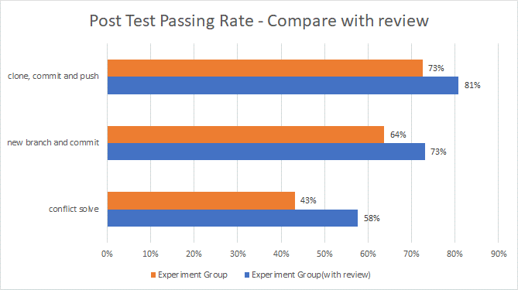
Figure 17 Post-test passing rate(compared to students with active learning)

5.4. Research Question 4 (RQ4): What do students think are the advantages and disadvantages of GEG?
For research question 4, we consolidated the OEQ1 and OEQ2 responses from the questionnaire, integrated similar feedback, and listed the strengths mentioned in the feedback:
- Fun is less boring and more motivated to learn ( 42% ).
- Easy to understand and know the mistakes, good to learn with feedback ( 30% ).
- The interface design is easier to get started, the website is convenient and good-looking ( 19% ).
- The learning difficulty is gradual, easier to learn ( 19% ).
The following are some of the deficiencies identified in the feedback:
- It will crash or get stuck ( 30% ).
- The instructions are simplified, so you may get it wrong when you really use it ( 30% ).
- Some hints or instructions are not clear, will not understand ( 30% ).
In addition, there was one feedback that mentioned wishing the course had more time and another feedback that some levels were too difficult (presumably because of level 8 and level 9).
Regarding these negative feedbacks, we plan to first find out when students are crashing according to the backend data, fix these situations, and return the simplified commands to the original Git commands to avoid students' confusion when using them in practice, and finally, strengthen the hints by demonstrating and adding more icons and descriptions in the instructions to make it easier for students to read and understand the game's level hints.

6. Conclusions
The ability to use version control software is crucial for software engineers, yet little attention has been paid to it in school education, and most of the related research has been done in conjunction with version control application software, while the game-based learning approach has considerable potential. Therefore, this study developed a serious game for educational Git, and designed and conducted an educational research experiment to evaluate the educational effect of the system, and designed a research model based on the UTAUT2 model to fit the data from the survey through PLS-SEM.
Based on the results of the study, we found that the group that included GEG as an educational aid had higher learning outcomes compared to the group that was taught by the traditional classroom alone, and that more than half of these students were active learners, and these students had higher learning outcomes compared to the overall experimental group. In addition, all the factors in the model, except for the hedonic motivation, had a significant direct effect on students' attitudes toward Git, and the gamification-related factors also had an indirect effect on students' attitudes toward Git, which in turn influenced students' behavioral intentions and subsequent behaviors.
For future research, we plan to change the content of the game so that it is closer to real Git commands when used, and to fix the problems mentioned in the feedback, such as crashes and unclear instructions. In addition, we plan to add more levels, which can be collectively called "challenges", to provide students with more opportunities to practice. By integrating the parts that are not easily understood by students into various contextual challenges, the game will grow from a simple introductory tool to a tool that can be used for both introductory and practice purposes. The gameplay part is to design more scenarios for the point mechanism and add more achievements and badges.

References
- Lassi Haaranen and Teemu Lehtinen. 2015. Teaching Git on the Side: Version Control System as a Course Platform. In Proceedings of the 2015 ACM Conference on Innovation and Technology in Computer Science Education (ITiCSE '15).
- Christiane Gresse von Wangenheim, Rafael Savi, Adriano Ferreti Borgatto, SCRUMIA—An educational game for teaching SCRUM in computing courses, Journal of Systems and Software, Volume 86, Issue 10, 2013, Pages 2675-2687, ISSN 0164-1212, https://doi.org/10.1016/j.jss.2013.05.030.
- V. Venkatesh, J. Y. L. Thong, and X. Xu, ‘‘Consumer acceptance and use of information technology: Extending the unified theory of acceptance and use of technology,’’ MIS Quart., vol. 36, no. 1, pp. 157–178, 2012.
- H. M. Lin, M. H. Lee, J. C. Liang, H. Y. Chang, P. Huang, and C. C. Tsai, ‘‘A review of using partial least square structural equation modeling in E- learning research,’’ Brit. J. Educ. Technol., vol. 51, no. 4, pp. 1354–1372, 2019.
- Fleming, T.M.; Bavin, L.; Stasiak, K.; Hermansson-Webb, E.; Merry, S.N.; Cheek, C.; Lucassen, M.; Lau, H.M.; Pollmuller, B.; Hetrick, S. Serious Games and Gamification for Mental Health: Current Status and Promising Directions. Front. Psychiatry 2017, 7, 215. [CrossRef] [PubMed]
- Uskov, A.; Sekar, B. Serious Games, Gamification and Game Engines to Support Framework Activities in Engineering: Case Studies, Analysis, Classifications and Outcomes. In Proceedings of the IEEE International Conference on Electro/Information Technology, Milwaukee, WI, USA, 5–7 June 2014; pp. 618–623.
- Fleming T, Cheek C, Merry S, Thabrew H, Bridgman H, Stasiak K, et al. Serious games for the treatment or prevention of
depression: a systematic review. Revista de Psicopatología y Psicología Clínica
(2014) 19(3):227-2.10.5944/rppc.vol.19.num.3.2014.13904 [CrossRef] [Google Scholar]
- Deterding S, Dixon D, Khaled R, Nacke L. From game design elements to gamefulness: defining gamification. Proceedings of the 15th International Academic MindTrek Conference: Envisioning Future Media Environments. Tampere: ACM; (2011). p. 9–15. [Google Scholar]
- Burke JW, McNeill MDJ, Charles DK, Morrow PJ, Crosbie JH, McDonough SM. Optimising engagement for stroke rehabilitation using serious games. Vis Comput (2009) 25(12):1085–99.10.1007/s00371-009-0387-4 [CrossRef] [Google Scholar]
- Chatham RE. Games for training. Commun ACM (2007) 50(7):36–43.10.1145/1272516.1272537 [CrossRef] [Google Scholar]
- Mayer, I. Playful Organisations & Learning Systems; Breda University of Applied Sciences: Breda, The Netherlands, 2016.
- Katie Seaborn and Deborah I. Fels. Gamification in theory and action. Int. J. Hum.-Comput. Stud., 74(C):14–31, February 2015.
- A. Radermacher and G. Walia. Gaps between industry expectations and the abilities of graduates. In Proceeding of the 44th ACM technical symposium on Computer science education, pages 525{530. ACM, 2013.
- J. Kelleher. Employing git in the classroom. In Computer Applications and Information Systems (WCCAIS), 2014 World Congress on, pages 1{4. IEEE, 2014.
- J. Lawrance and S. Jung. Git on the cloud. Journal of Computing Sciences in Colleges, 28(6):14{15, 2013.
- Michael D. Hanus and Jesse Fox. Assessing the effects of gamification in the classroom: A longitudinal study on intrinsic motivation, social comparison, satisfaction, effort, and academic performance. Computers & Education, 80:152–161, 2015
- Juho Hamari, Jonna Koivisto, and Harri Sarsa. Does gamification work? – a literature review of empirical studies on gamification. In Proceedings of the 2014 47th Hawaii International Conference on System Sciences, HICSS ’14, pages 3025–3034, Washington, DC, USA, 2014. IEEE Computer Society.
- J. F. Hair, C. M. Ringle, and M. Sarstedt, ‘‘PLS-SEM: Indeed a silver bullet,’’ J. Marketing Theory Pract., vol. 19, no. 2, pp. 139–152, Apr. 2011.
- H. M. Lin, M. H. Lee, J. C. Liang, H. Y. Chang, P. Huang, and C. C. Tsai, ‘‘A review of using partial least square structural equation modeling in E- learning research,’’ Brit. J. Educ. Technol., vol. 51, no. 4, pp. 1354–1372, 2019.
- F.-H. Huang, ‘‘Adapting UTAUT2 to assess user acceptance of an e- scooter virtual reality service,’’ Virtual Reality, vol. 24, no. 4, pp. 635–643, Dec. 2020.
- V. Venkatesh, M. G. Morris, G. B. Davis, and F. D. Davis, ‘‘User acceptance of information technology toward a unified view,’’ MIS Quart., vol. 27, pp. 425–478, Jul. 2003.
- J. F. Hair, C. M. Ringle, and M. Sarstedt, ‘‘Partial least squares structural equation modeling: Rigorous applications, better results and higher accep- tance,’’ Long Range Planning, vol. 46, nos. 1–2, pp. 1–12, 2013.
- K. K. K. Wong, ‘‘Partial least squares structural equation modeling (PLS- SEM) techniques using SmartPLS,’’ Marketing Bull., vol. 24, no. 1, pp. 1–32, 2013.
- J. F. J. Hair, G. T. M. Hult, C. M. Ringle, and M. Sarstedt, ‘‘A primer on partial least squares structural equation modeling (PLS-SEM),’’ Eur.J. Tourism Res., vol. 6, pp. 211–213, Dec. 2014.
- V. Venkatesh, M. G. Morris, G. B. Davis, and F. D. Davis, ‘‘User acceptance of information technology toward a unified view,’’ MIS Quart., vol. 27, pp. 425–478, Jul. 2003.
- S. A. Salloum, M. Al-Emran, A. A. Monem, and K. Shaalan, ‘‘Explor- ing students’ acceptance of E-learning through the development of a comprehensive technology acceptance model,’’ IEEE Access, vol. 7, pp. 128445–128462, 2019.
- K. Tamilmani, N. P. Rana, and Y. K. Dwivedi, ‘‘Consumer acceptance and use of information technology: A meta-analytic evaluation of UTAUT2,’’ Inf. Syst. Frontiers, vol. 23, no. 4, pp. 987–1005, Aug. 2021.
- Baptista, Goncalo & Oliveira, Tiago. (2017). Why so serious? Gamification impact in the acceptance of mobile banking services. Internet Research. 27. 118-139. 10.1108/IntR-10-2015-0295.
- Star, K. 2016. Gamification, Interdependence, and the Moderating Effect of Personality on Performance. Doctoral Thesis. University of Coventry.
- Zichermann, G., & Linder, J. 2010. Game-based marketing: inspire customer loyalty through rewards, challenges, and contests. John Wiley & Sons.
- A. Baker, E. O. Navarro and A. van der Hoek, "An experimental card game for teaching software engineering," Proceedings 16th Conference on Software Engineering Education and Training, 2003. (CSEE&T 2003)., 2003, pp. 216-223, doi: 10.1109/CSEE.2003.1191379.

